# - What is an algorithm? Provide a formal definition.

- An algorithm is a step-by-step procedure or set of rules to solve a problem or perform a task in a finite number of steps.

- - List and explain the key characteristics of an algorithm.

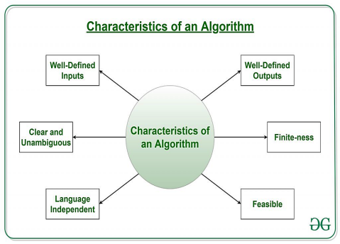

- Finite: Must terminate after a finite number of steps.
- Definite: Each step must be clearly defined.
- Input: Can have zero or more inputs.
- Output: Must produce at least one output.
- Deterministic: Same input always gives the same output.
- Effective: Every step must perform a meaningful task.

- - Why is it important for an algorithm to be deterministic?

- Ensures consistency: The same input always produces the same output.
- Predictability: Helps in debugging and verifying correctness.

- - Discuss the applications of algorithms .

- Computer Science: Used in programming, AI, and machine learning.
- Mathematics: Solves linear equations, finds shortest paths in graphs.
- Operations Research: transportation, logistics, and resource allocation.
- Data Science: Analyzes, processes, marketing, finance, and healthcare.

- - How are algorithms used in Mathematics/computer science? Provide examples.

(Applications in computer science)
- Programming: Writing efficient code.
- AI & Machine Learning: Training models, decision-making.
- Data Structures: Sorting, searching, and organizing data.

( Applications in Mathematics)
- Linear Algebra: Solving systems of equations.
- Graph Theory: Finding the shortest path (e.g., Dijkstra's algorithm).
- Optimization: Maximizing or minimizing functions.

- How to Design an Algorithm?

Design: Focuses on creating algorithms to solve a specific problem.

- Understanding the Problem: Define the problem clearly.
- Choosing a Strategy: Select an approach (e.g., divide and conquer).
- Developing the Algorithm: Write step-by-step logic.
- Verification: Ensure correctness with test cases.

- How to Analyze an Algorithm?

Analysis: Focuses on evaluating the performance and efficiency of an algorithm.

- Correctness: Ensures the algorithm produces the right output.
- Complexity Analysis: Evaluates time and space efficiency.
- Best/Worst/Average Case Analysis: Measures performance in different scenarios.
- Comparative Analysis: Compares efficiency with other algorithms.

- - Explain the concept of time complexity and space complexity.

- Time Complexity: Measures how long an algorithm takes to run based on input size.
- Space Complexity: Measures how much memory an algorithm uses based on input size.

- - What is the difference between best case, worst case, and average case analysis?

- Best Case: Minimum time/space required (ideal scenario, e.g., input is already sorted).
- Worst Case: Maximum time/space required (most challenging scenario, e.g., input is in reverse order).
- Average Case: Expected time/space required over all possible inputs (typical scenario).

- - Define time complexity and provide an example of how it is calculated.

- Time Complexity: Measures the time taken by an algorithm as a function of input size.
- Example: A loop running n times has a time complexity of O(n).

- - Define space complexity .

- Space Complexity: Measures the amount of memory an algorithm uses as a function of input size.
- Includes fixed space and variable space (e.g., dynamic memory).

- - What are the advantages/dis of using algorithms in problem-solving?

- Easy to understand
- Serve as a blueprint
- Simple to debug
- Not dependent on programming language

(DisAdvantage)

Time & Space Complexity: Some algorithms require too much time or memory.
Difficult Representation: Branching and looping logic can be hard to express.

